Python Student Progress and Performance Tracking System
You will develop a Python-based student progress tracking system aimed at improving monitoring and evaluation of student performance within an educational environment.
The application should provide functionality to track academic progress, manage assignments, and generate performance reports. The system should allow students to view their progress and enable teachers to monitor and support student development effectively.

1. Student Profile Management:
• Manage student profiles, including adding, viewing, editing, and deleting records.
• Capture essential student information such as name, student ID, course, and contact details.
• Maintain structured records for easy access and efficient management.

2. User Registration and Authentication:
• Implement a secure login system for users.
• Allow different user roles such as students and teachers.
• Ensure that only authorized users can access and modify data.

3. Assignment Management:
• Allow teachers to create and assign tasks or assignments.
• Enable students to view assigned tasks and submit their work (basic submission status).
• Track assignment deadlines and completion status.

4. Marks and Performance Tracking:
• Record and manage student marks for assignments and tests.
• Provide a summary of student performance.
• Allow students to view their individual results.

5. Report Generation:
• Generate simple performance reports for each student.
• Include:
- Total marks
- Average score
- Completion rate
• Help teachers analyse student progress effectively.

6. Notifications:
• Implement basic notifications for:
- Assignment deadlines
- Result updates
• Keep students informed about their academic activities.

Basic Academic Tools:
Include at least one tool such as:
• Grade calculator
• Average marks calculator
These tools should help students understand their academic performance.

User Interface:
Develop a user-friendly interface using Python libraries such as:
- Tkinter
- PyQt
Ensure:
• Simple navigation
• Clear data display
• Easy input forms

Testing and Validation:
Conduct thorough testing to identify and fix bugs.
Validate the application's functionality against predefined test cases.

Deployment: Consider deployment options, such as standalone/web application.
Submission Guidelines:
- Submit the Python source code along with any necessary documentation.
- Include a brief report summarizing the design decisions, challenges faced, and lessons learned during the development process.

1.Understand how software is used and the problems that it can solve.
1.1 Describe a range of scenarios for the development of a software solution (app, web platform, embedded system, etc)
1.2 Identify potential software solutions to a range of real-life problems.

Developing a student management system in Python can involve various scenarios depending on the specific requirements, scale, and complexity of the project. Explain in detail about the development process for the given scenario.
Requirement Gathering and Analysis
Design Phase: Draw a Use case diagram for your scenario.
Technology Stack Selection
Development
Testing
Deployment
Configure monitoring systems to ensure continuous operation.
Training and User Adoption:
Maintenance and Updates:
Customization and Expansion:

2. Be able to take on a role within a software team.

Describe software team roles (e.g. product owner, solutions architect, lead developer, developers, designers, testers, data analysts)
2.2 Adopt a designer/developer/tester role within a project team.
2.3 Use common tools for communication within the team

2.1 Explore the roles within a software development team, understand the responsibilities associated with each role, and actively participate in a simulated project team environment. For each role, outline your responsibilities, skills required, and how they contribute to the overall success of a software project.

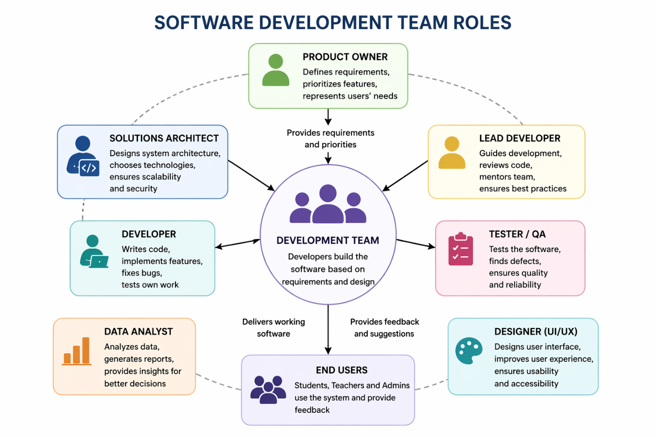

A software development team includes different roles, and each role has specific responsibilities that help the project succeed. In a project such as the Python Student Progress and Performance Tracking System, every team member contributes to building a useful, reliable, and user-friendly system.
1. Product Owner
The product owner is responsible for understanding what the users need and making sure the project delivers value. In this project, the users are mainly teachers and students.
Responsibilities
- Gather requirements from users
- Decide which features are most important
- Prioritise tasks for the team
- Make sure the final product meets the project goals

Skills Required
- Communication
- Decision-making
- Problem-solving
- Understanding user needs
Contribution to Project Success
The product owner helps the team stay focused on the most useful features, such as student profile management, assignment tracking, marks recording, and report generation. This helps avoid wasted time and ensures the software solves a real problem.
2. Solutions Architect
The solutions architect plans the overall structure of the system. They decide how different parts of the software will work together.
Responsibilities
- Design the system structure
- Choose suitable technologies
- Plan how data will be stored
- Ensure the system is secure and efficient
Skills Required
- Technical knowledge
- System design
- Database knowledge
- Analytical thinking
Contribution to Project Success
The solutions architect ensures the Python system has a clear design. For example, they may decide how user login, assignment records, and performance reports connect together. A good design makes the application easier to build, test, and improve later.

3. Lead Developer
The lead developer guides the programming side of the project and supports the rest of the developers.
Responsibilities
- Lead coding decisions
- Organise development tasks
- Review code quality
- Support other team members with technical problems
Skills Required
- Strong Python programming
- Leadership
- Debugging
- Code review
Contribution to Project Success
The lead developer ensures the code is well organised, readable, and works correctly. This is important for a system that stores student data and calculates marks accurately.
4. Developer
The developer writes the code that makes the system function.
Responsibilities
- Build features such as login, profile management, and report generation
- Fix bugs
- Connect the interface with the program logic
- Test code during development
Skills Required
- Python programming
- Attention to detail
- Debugging
- Logical thinking
Contribution to Project Success
The developer turns the project plan into a working system. Without developers, the project cannot be built. They create the actual functions for adding students, viewing marks, and managing assignments.
5. Designer
The designer focuses on the appearance and usability of the application.
Responsibilities
- Create the layout of the user interface
- Make the system easy to navigate
- Design forms, buttons, and screens
- Improve user experience
Skills Required
- Creativity
- User interface design
- Understanding of user needs
- Attention to layout and accessibility
Contribution to Project Success
The designer helps make the application simple and clear. In this project, that is important because both teachers and students need to use the system easily. A confusing interface would reduce the usefulness of the software.
6. Tester
The tester checks whether the system works correctly and finds problems before release.
Responsibilities
- Test features and functions
- Identify bugs and errors
- Check whether the software meets requirements
- Record test results
Skills Required
- Attention to detail
- Patience
- Analytical thinking
- Understanding test cases
Contribution to Project Success
The tester improves quality by making sure features such as login, adding records, assignment tracking, and grade calculation work properly. Testing helps prevent errors and improves reliability.
7. Data Analyst
The data analyst focuses on how information is organised, interpreted, and used.
Responsibilities
- Analyse student performance data
- Check that reports are meaningful
- Support decisions using data
- Help improve reporting features
Skills Required
- Data handling
- Analytical thinking
- Accuracy
- Understanding of reporting

Contribution to Project Success
In this project, the data analyst helps ensure that marks, averages, and completion rates are clear and useful. This supports teachers in monitoring student progress effectively.

Conclusion
Each role in a software development team is important. The product owner defines what is needed, the architect designs the structure, developers build the system, designers improve usability, testers ensure quality, and data analysts make the reporting meaningful. When these roles work together, the project has a much greater chance of success.

2.2 Describe how you would adopt this role within a project team scenario and discuss the specific tasks and responsibilities you would undertake in this role.

In this project, I was assigned the role of Developer rather than choosing it myself. This helped me understand how roles are allocated in real software teams, where tasks are often assigned based on project needs rather than personal preference. By working in this role, I gained practical experience in coding and implementing features, particularly in building a student registration and verification system.
As a developer, my responsibility was to turn the project requirements into a functional Python application. I used the Tkinter library to create a graphical user interface and implemented key features such as user registration, verification, and login.
Tasks I undertook in this role
1. Creating the registration system
I developed a feature that allows users to register by entering:
- name
- email
- password
- role (student or teacher)
The system checks:
- if fields are empty
- if the email is valid
- if the user already exists
This ensures that only valid users can be registered.

2. Implementing email verification logic
I created a verification system where:
- a random 6-digit code is generated
- the code is stored with the user data
- the code expires after 10 minutes
In my project, email sending is simulated using a popup message and console output instead of real email integration.
This allowed me to test the logic without needing external services.

3. Building the verification process
I developed a function that allows users to:
- enter their email
- input the verification code
The system checks:
- if the user exists
- if the code is correct
- if the code has expired
If successful, the user is marked as verified.

4. Adding a resend code feature
I implemented a feature that allows users to request a new verification code if:
- the code has expired
- or the user did not receive it
This improves usability and ensures users can still access their accounts.

5. Creating the login system
I developed a login feature that:
- checks if the user exists
- verifies that the account is verified
- checks if the password is correct
Only verified users are allowed to log in, which improves system security.

6. Designing the user interface
Using Tkinter, I created multiple screens:
- registration screen
- verification screen
- login screen
I used buttons and input fields to make navigation simple and clear for users.

7. Testing my code
I tested the system by:
- registering users
- verifying accounts
- logging in
- checking error messages
This helped identify and fix issues such as incorrect inputs or expired codes.

How I worked within the team
Even though I worked mainly on coding, I still collaborated with the team by:
- discussing what features were needed
- updating others on my progress
- sharing my code
- listening to feedback
This ensured my part of the system worked well with the rest of the project.

Skills I used and developed
During this task, I used and improved:
- Python programming
- problem-solving
- debugging
- logical thinking
- basic UI design with Tkinter

Conclusion
By adopting the developer role, I successfully created a student registration and verification system as part of the larger project. Even though the role was assigned to me, I adapted to it and contributed by building a working and testable feature that supports user authentication and security.

2.3 Select common communication tools used in software development teams
• Explain the purpose and features of each tool.
• Describe how you would utilize these tools to communicate and collaborate effectively within a project team.
• Provide examples of how these tools can facilitate task management, information sharing, and team coordination.
(Provide Screenshots that how you communicate to facilitate task management, information sharing, and team coordination.)

Software development teams use communication tools to share information, manage tasks, and work together efficiently. In a project team, these tools are important because they improve organisation, reduce misunderstandings, and help team members stay updated.
Below are common communication tools that can be used in a software development project.
1. Microsoft Teams
Microsoft Teams is a communication platform used for messaging, online meetings, file sharing, and team collaboration.
Purpose and Features
- Instant messaging
- Video calls and meetings
- Group chats
- File sharing
- Channels for different topics
How I would use it
I would use Microsoft Teams to communicate with team members during the project. For example, I could send updates about my coding progress, ask questions, and join meetings to discuss tasks.
How it supports collaboration
- Helps the team discuss project issues quickly
- Makes it easy to share files and documents
- Allows team meetings even when people are in different locations
Example
If I completed the login system, I could send a message in Teams to let the group know it is ready for testing.
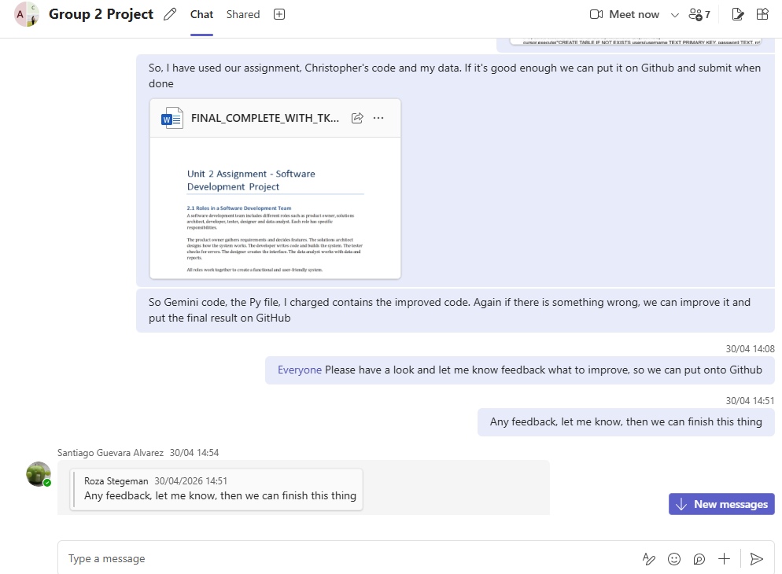
3. GitHub
GitHub is a platform used for code sharing, version control, and collaboration between developers.
Purpose and Features
- Stores project code online
- Tracks changes to files
- Supports branches and pull requests
- Allows code review
- Keeps a history of updates
How I would use it
I would use GitHub to upload my code, create branches for new features, and share changes with the team. This would allow other team members to review my code and combine it into the main project safely.
How it supports collaboration
- Prevents team members from overwriting each other’s work
- Makes it easy to review and improve code
- Supports teamwork when several people are working on different parts of the same project
Example
If I created the assignment tracking feature, I could push it to GitHub on a separate branch and ask the team to review it before merging it into the main version.
Screenshot to add:
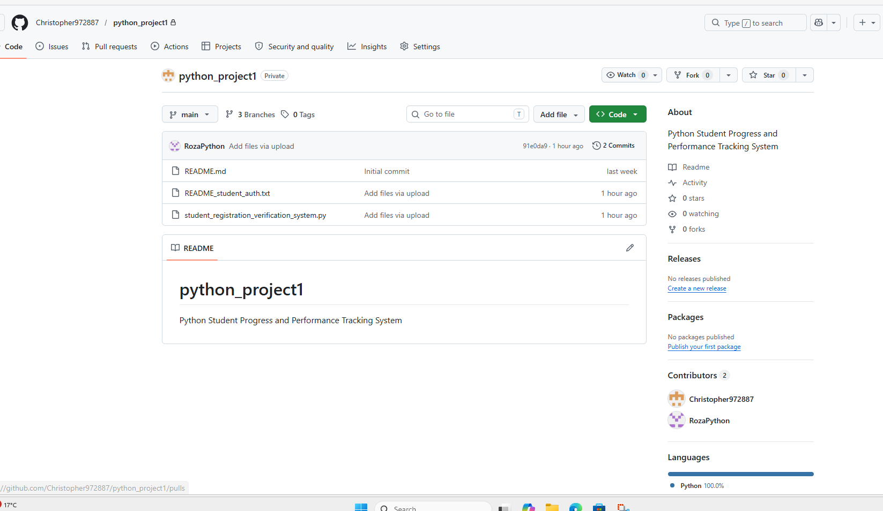

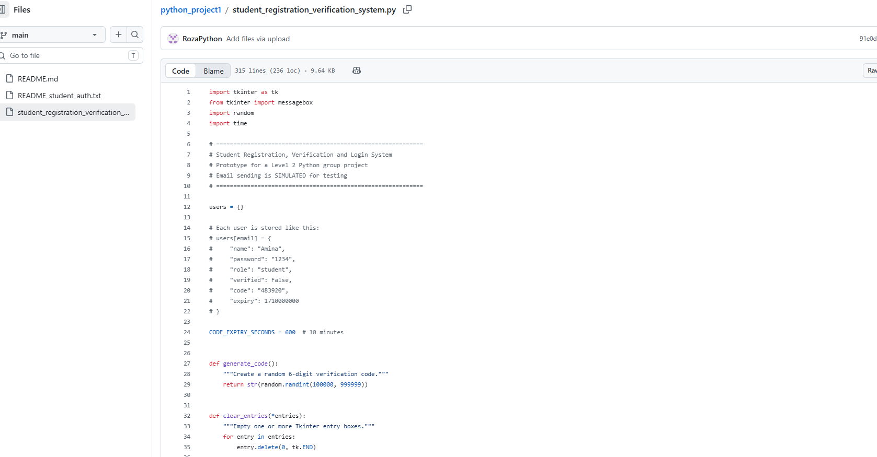

Task 3
Be able to participate in the project management and code sharing process (Agile/ SCRUM/ version control)

3.1 Use a Git-based version control system to contribute to a shared code base.
3.2 Contribute to planning, reflecting and managing own work.
3.3 Respond to a code review with questions and confirmation of changes to code.

Utilize Git-based version control, participate in planning and reflection activities, and engage in a code review process.
3.1 Explain the importance of version control in software development.
Provide a step-by-step guide on how to clone a repository, create a new branch, make changes, commit those changes, and push them to the remote repository. Discuss best practices for collaborating with team members using Git and resolving conflicts.
(Screenshots or demonstrations of using Git for version control and participating in planning, reflection, and code review processes.)

Repository creation, then apply rules against deletion for example. Assigning reviewers, create pull requests and signed commits.
Hereby some extra screenshots and explanation after creating a new repository.(Already explained in the text).
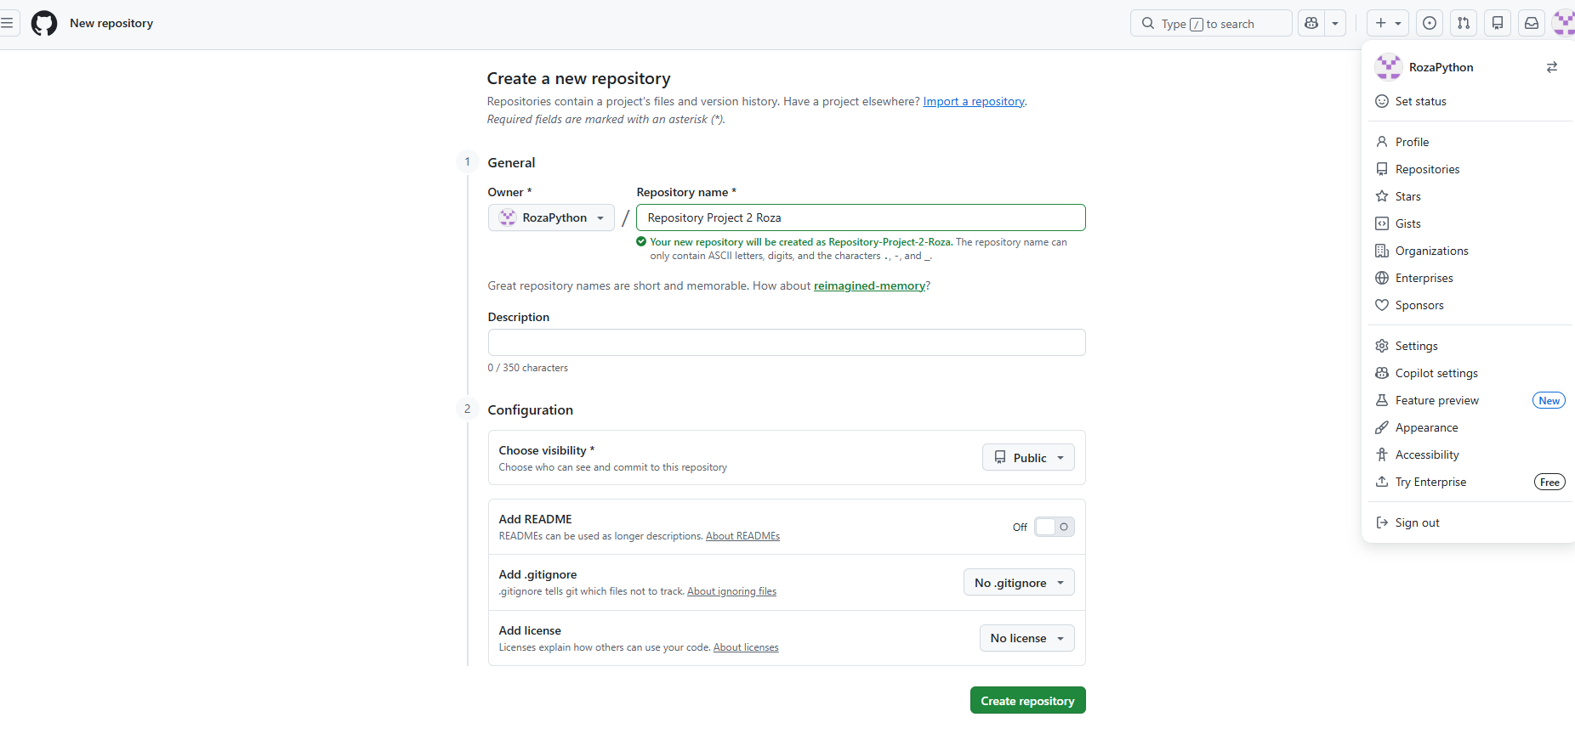

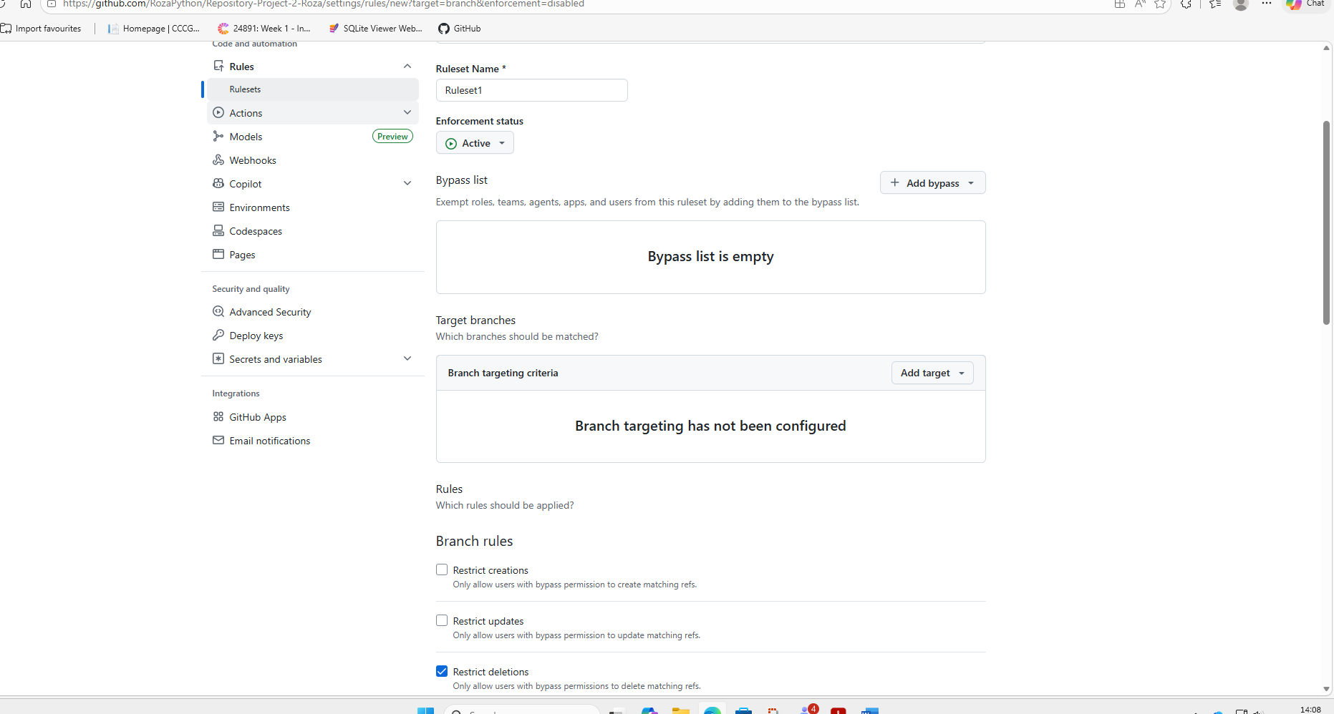

New Branch
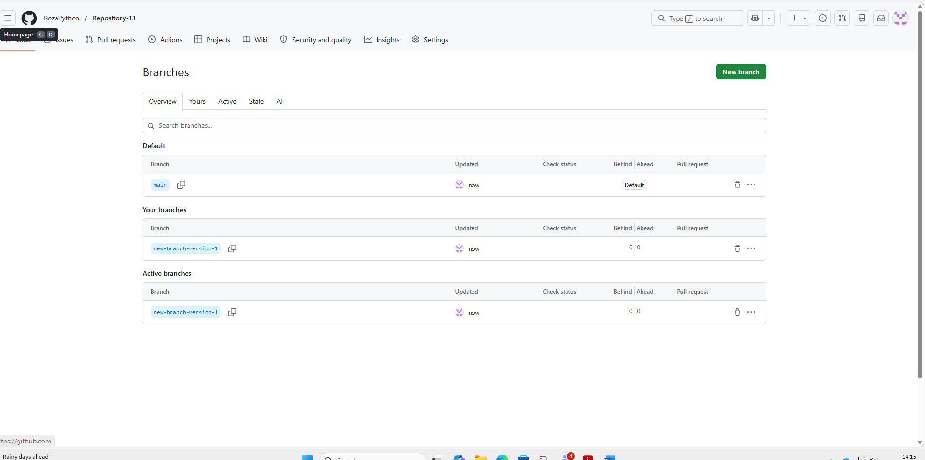

Pull request

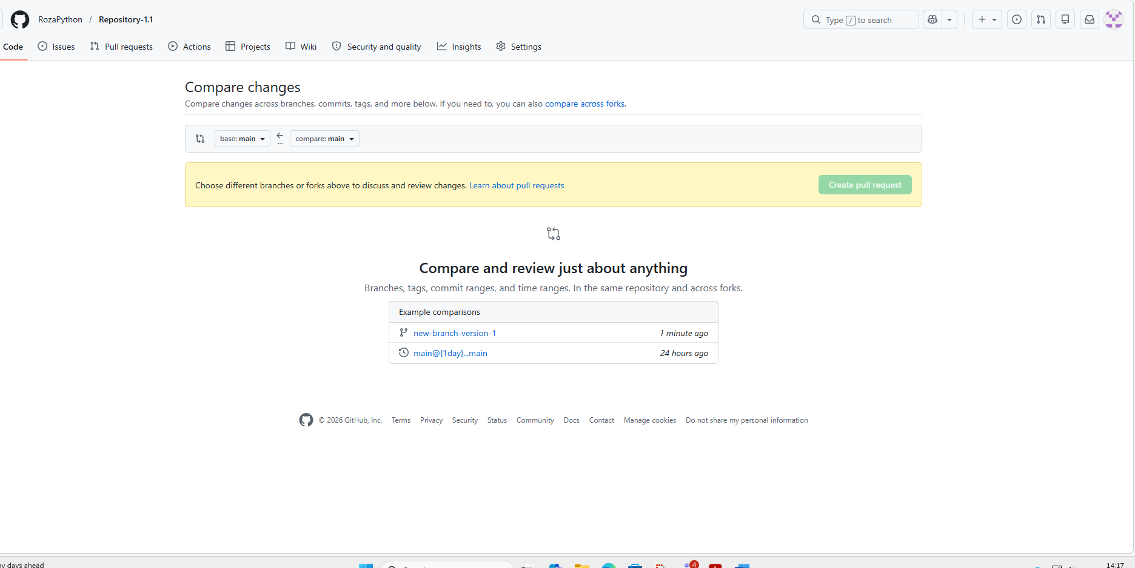

Commit

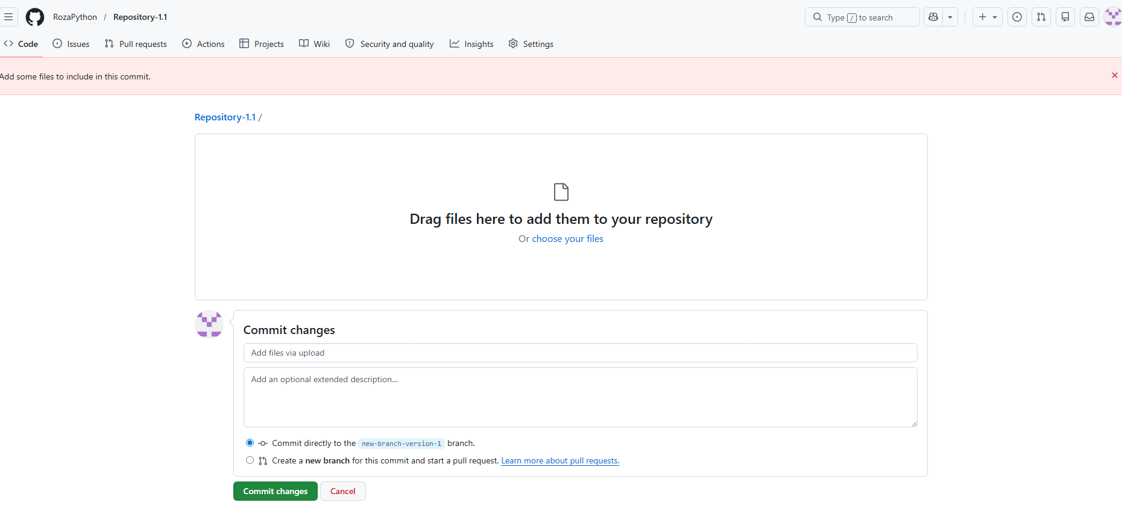

3.2 Reflect on your own work habits and strategies for managing tasks and deadlines within a software development project. (Develop a action plan for the task and mention the deadlines)
Task | Start Date | Duration | End Date
Which project and peers?
Action Plan and Design
Design Review
Create promotional product/ Party
Implementation and Testing Review
Execute project
Project Review
Review Meeting
Feedback from peers
Final Deadline

3.3 Explain how you would respond to feedback received during a code review, including asking questions for clarification and confirming changes made to the code.

Screenshots or demonstrations of using Git for version control and participating in planning, reflection, and code review processes.
Here are the 3 steps to create a new repository. Step one. Go to settings and click on Repositories.
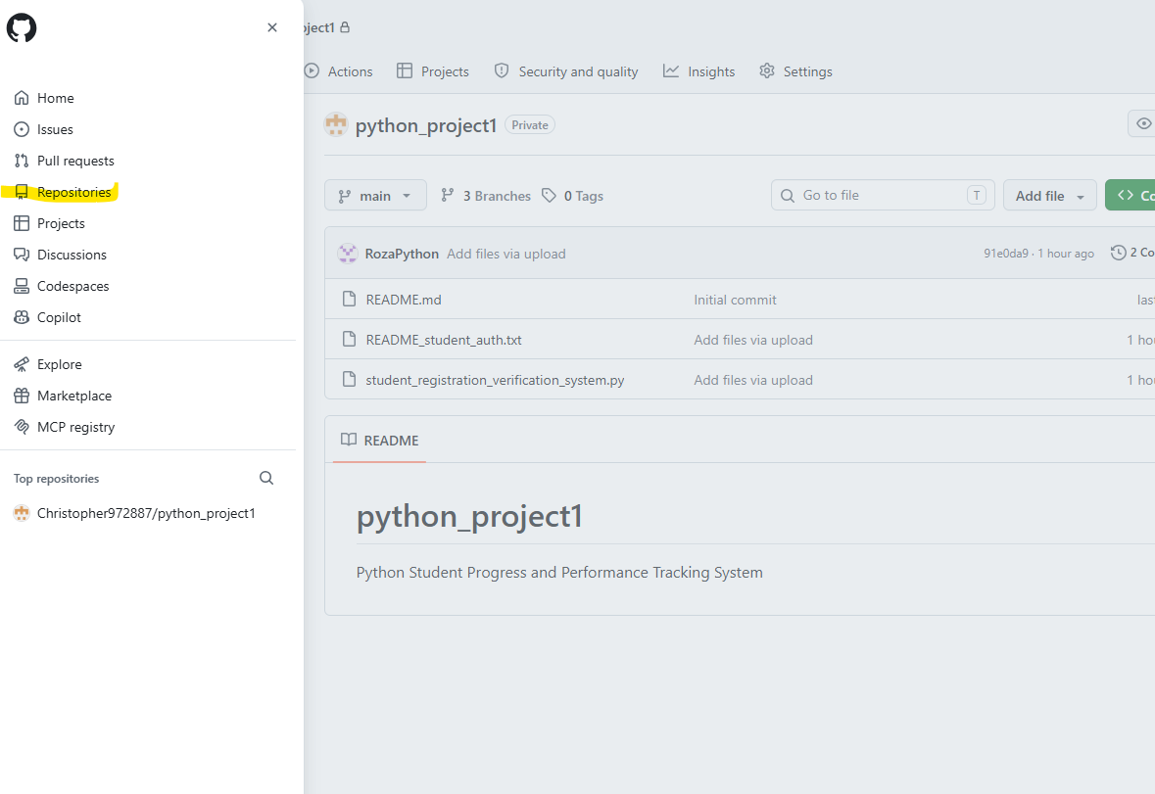

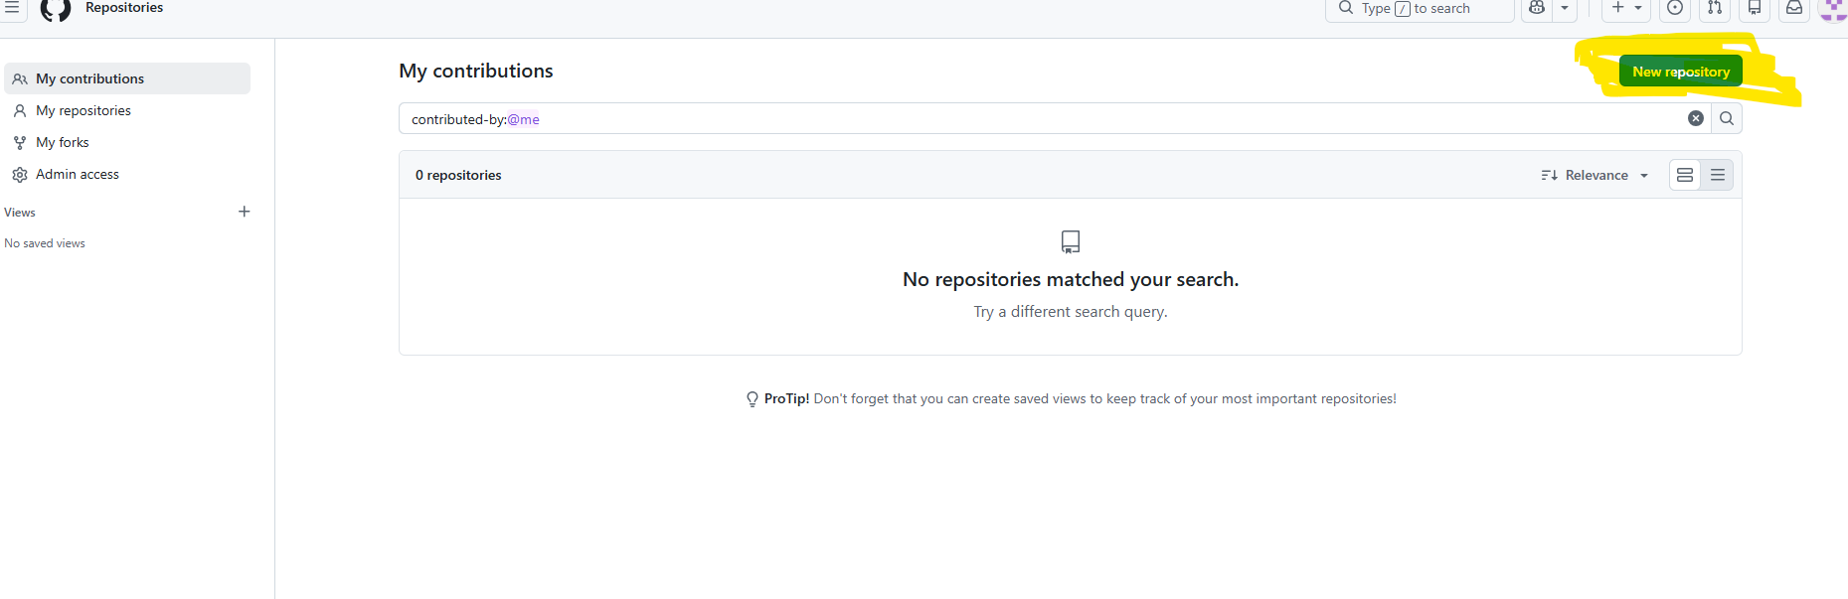
Step 2. Click on New Repository.
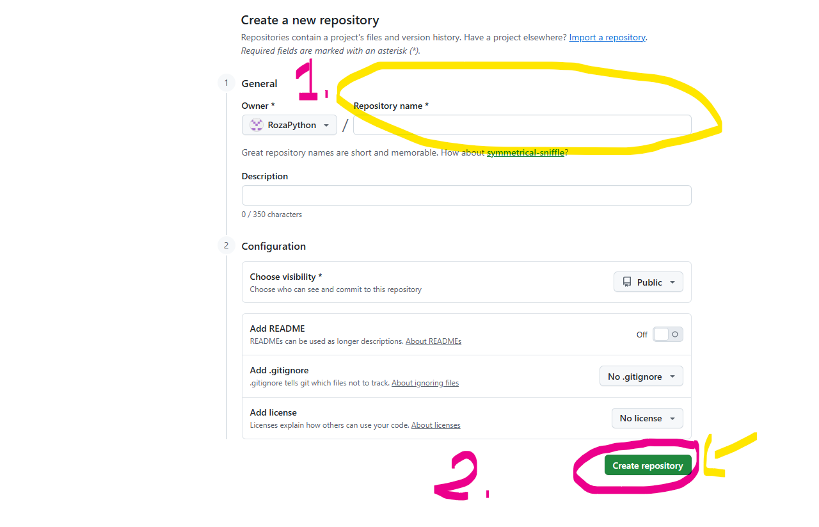
Step 3: Fill in a Title and click on Create Repository.

Communication Screenshots GitHub




Communication screenshots Teams

